INITIAL UPDATE
Parking Guard application
Application requirements
- Database storage
  - Firebase
    - Firestore database
    - Authentication
- User interface for admin Web application
  - HTML, CSS, Javascript
- User interface for users
  - Meron akung 2 option na pinag iisipan if gagamit ako ng
    - Flutter or
    - HTML, CSS, JavaScript pero converter yung android app by Ionic
To set up admin web application here is the command to setup
- npm install firebase-tools -g
- firebase init hosting
- firebase login
- firebase login # if you haven't logged in yet
- firebase projects:list # see the projects you can access
- firebase use Sample
- firebase services
- firebases deploy here is the commant if need mo I deploy yung application sa online

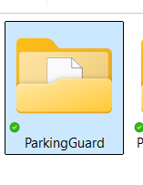
Here is the sample to run the command create filter den run the command

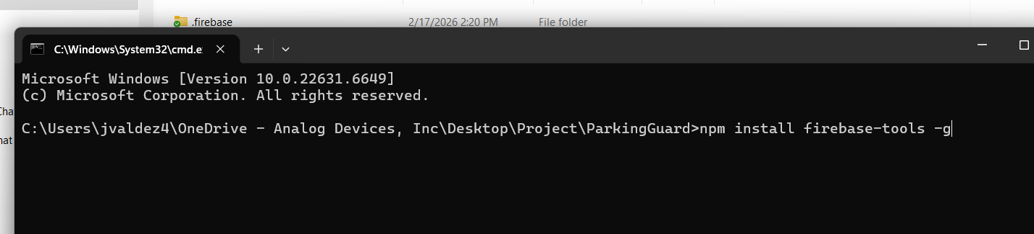
Here is the Database project ParkingGuard
- Tables
  - parking_slot: This is table storage for sparking slot
  - users: This is table storage for users
  - vehicle: this is table storage for vehicle
  - Authentication: This is table storage for user’s login
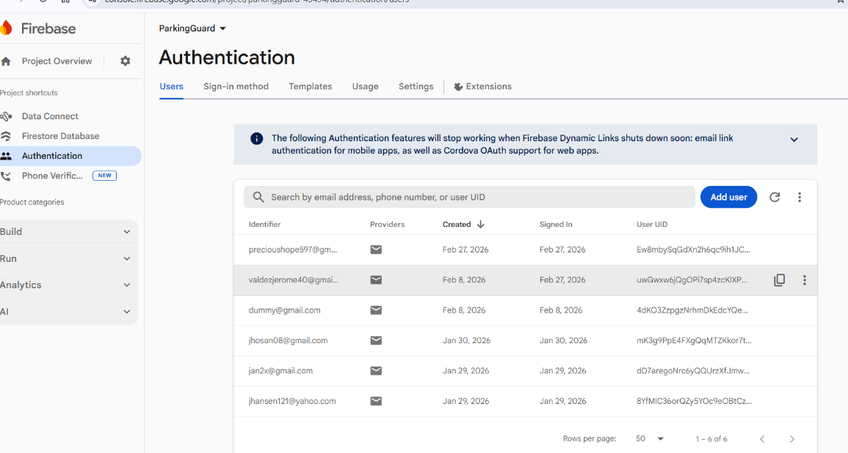

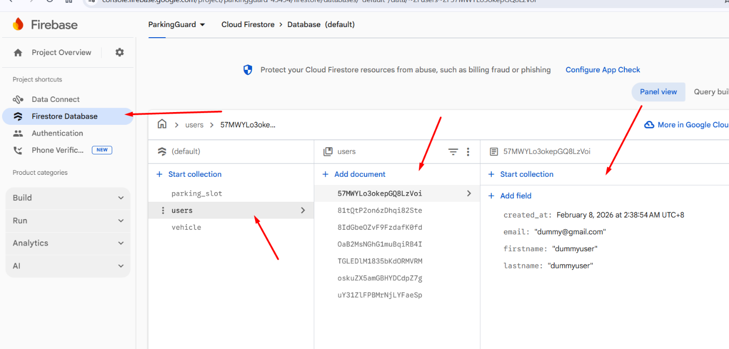

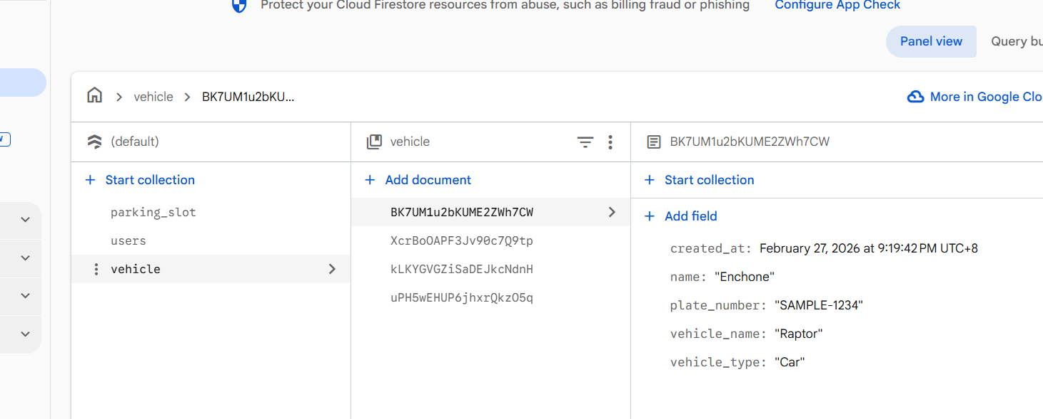

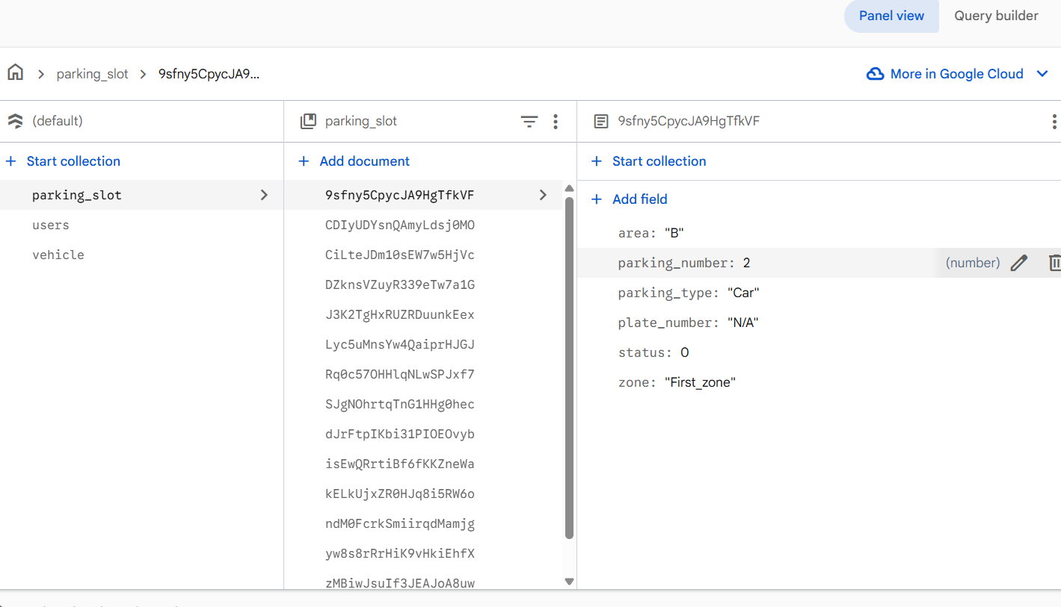

User interface: Registration form, Login
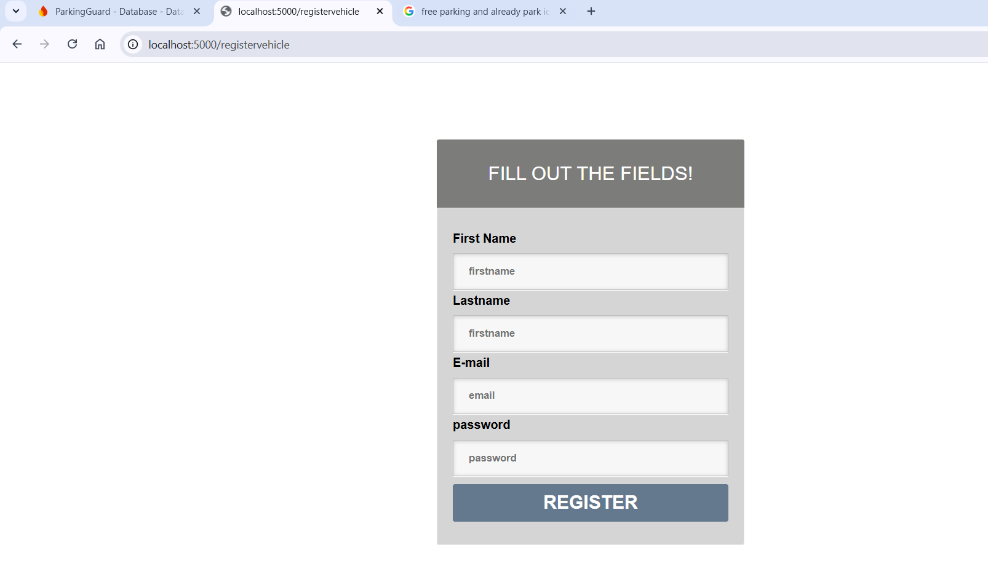

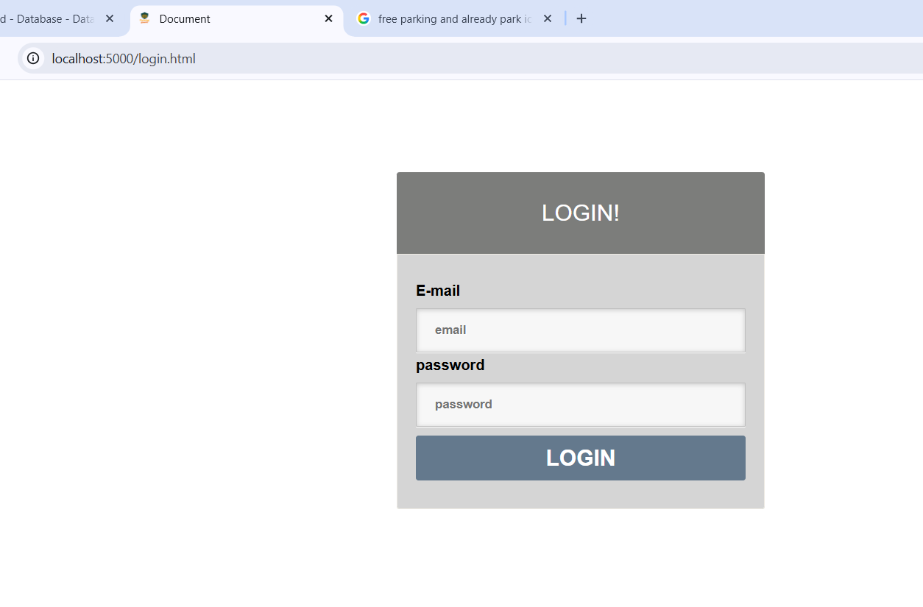

Admin web user interface
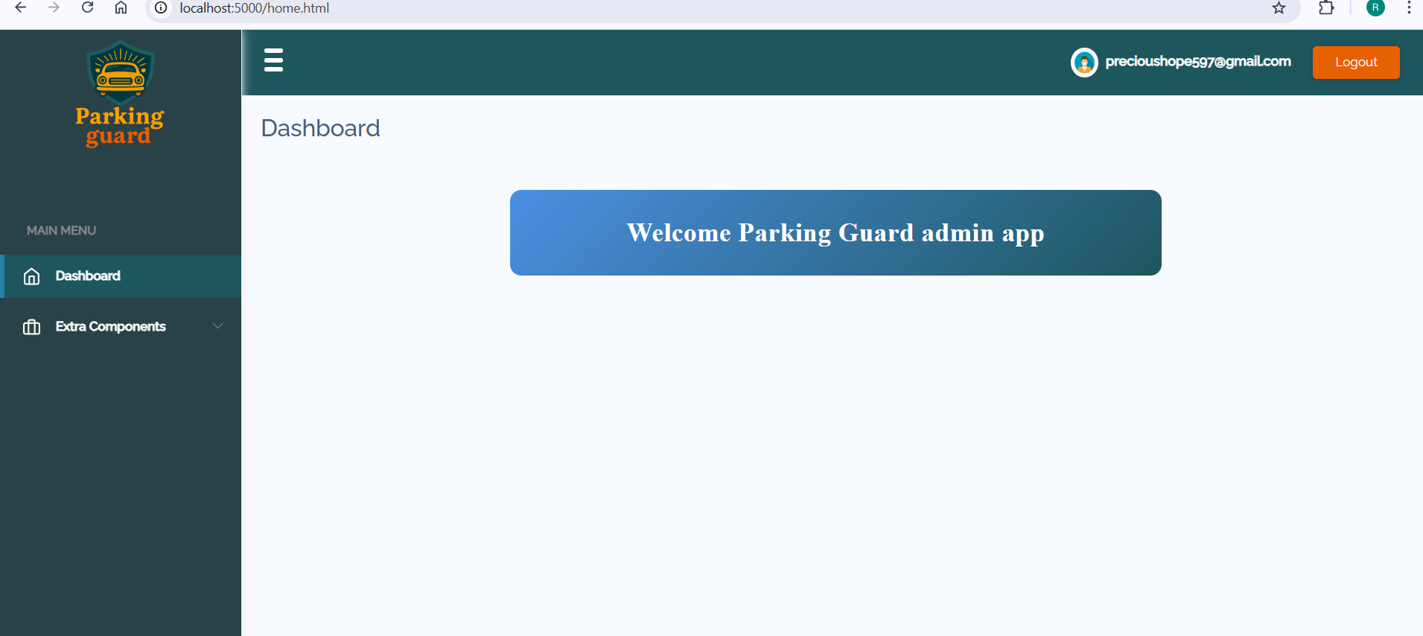

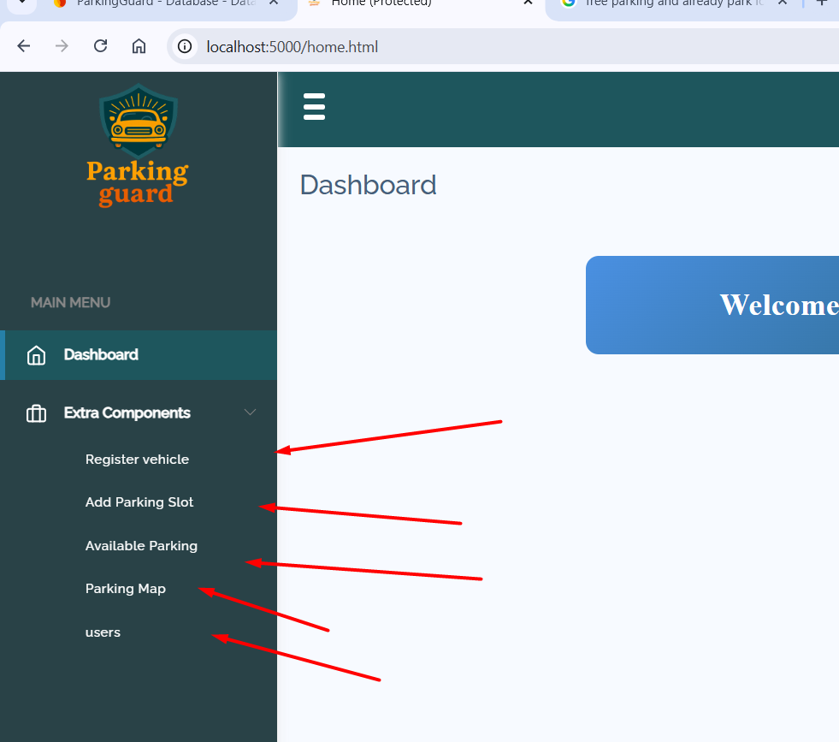

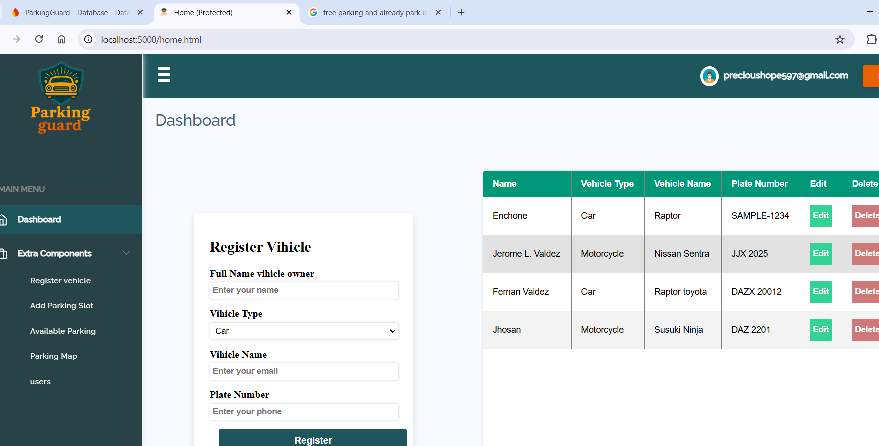

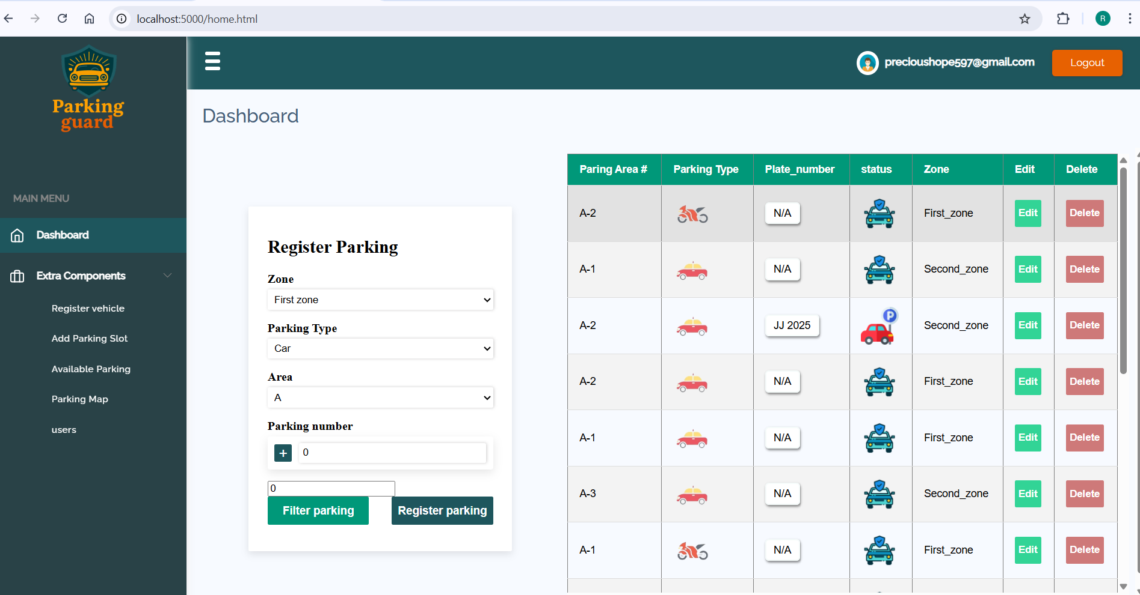

NOTE:

Here is the remaining features
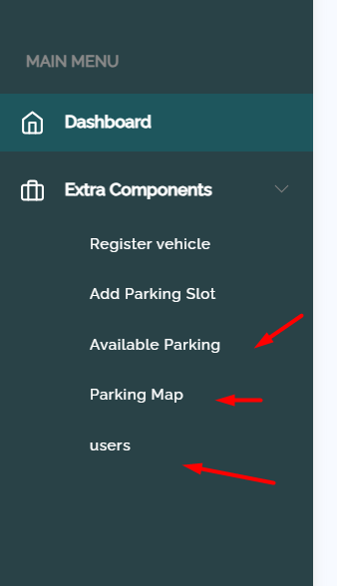

- Create user android interface for regular users
- Create user tab for android application for Guard users to approve parking space

Code structure
Here is the code structure
